Multi-photon usage on SP5

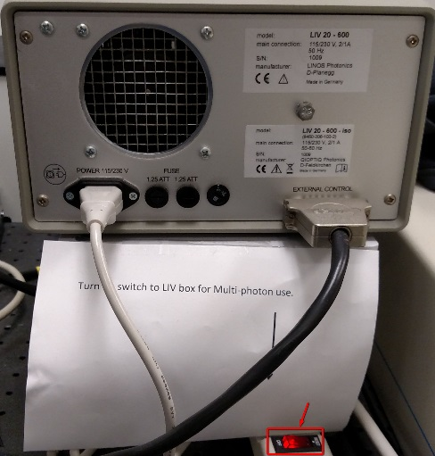
- Before starting the LAS-AF software, turn on the MP laser key switch on the air-table next to the microscope. The switch is on the power strip to make it easier to reach. The actual switch is on the other side of the box.

- Turn on the MP laser power. The keyed switch is on the unit below the air-table. Only turn the laser key. Do not turn the power switches on either the laser or the chiller below. It can take hours to stabilize again if either of them is turned on from a cold start.
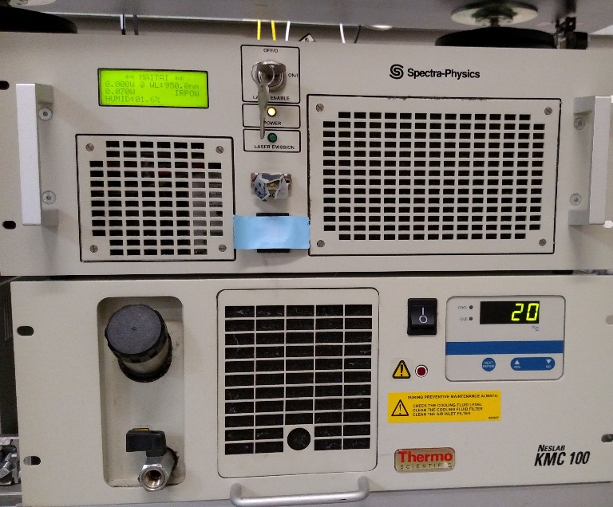
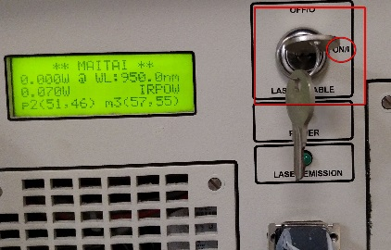

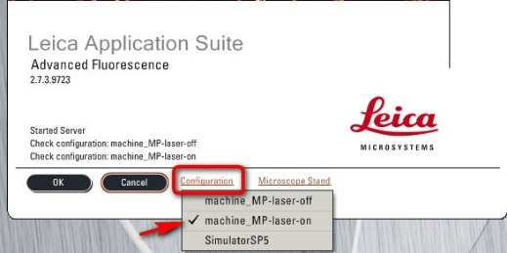
- Log into the computer if you haven’t already done so. Start the LAS-AF software and at the splash screen, select the configuration option. It is here that you select the MP-Laser ON option. If this option is not set to MP-Laser ON, there will be NO option to select it once the LAS-AF is ready.

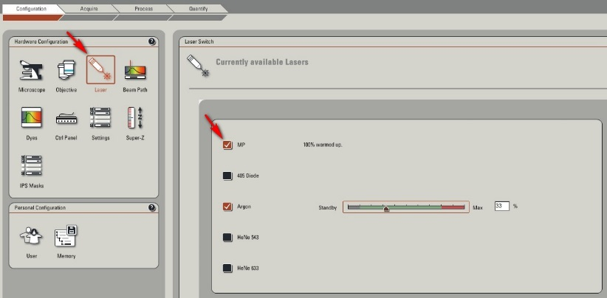
- Once the software has completely loaded, select the “configuration” tab and go to the “Laser” option. You should see the MP Laser listed and at this point, check the box to make it available.

- Click on the “Acquire” tab to bring up the main screen. Click on the MP-Laser button to bring up the dialog box to get the laser ready for use by opening the shutter. You will need to hold the MP-Laser Shutter button down for several seconds until it lights up and the Emissions warning triangle also lights up. At this point the mode may be set to “CW” (Continuous Wave mode). It is not ready for MP use until it changes to “Pulse” mode. It is at this screen that you set the wavelength. Use the slider, or type in a number in the wavelength setting box. You need to also click the “Tune” button to complete the setting procedure. Select a wavelength by trial and error based on approximately 2X the wavelength needed for a single photon to cause the molecule of interest to fluoresce. See the published tables to guide you.

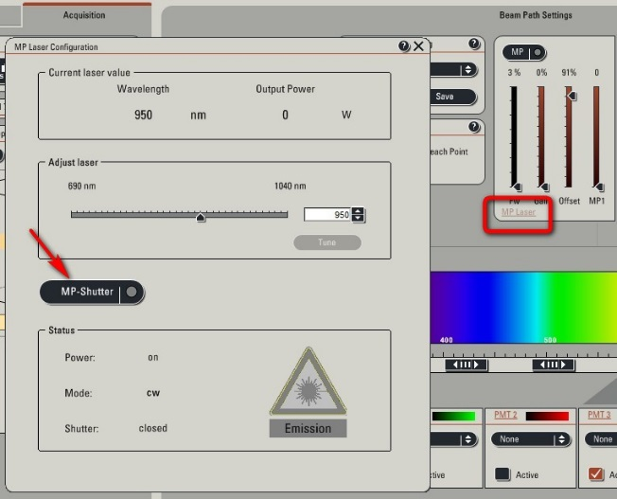

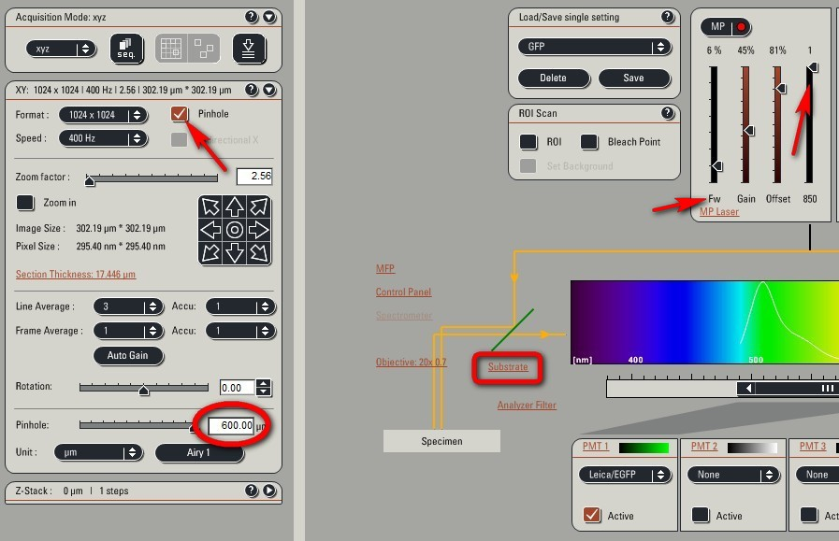
- Close the dialog box. You can now select one of the preset MP options in the “Load/Save Single Setting” drop down. It is convenient to start with one of those choices and modify it. In the “XY” setting window, click the “Pinhole” box to active the pinhole setting submenu. When using the MP laser, the pinhole should be set to fully OPEN. And, the dichroic filters are not needed, so select the “Substrate” option. The last step before clicking the “Live” button is to move the slider in the MP window from the bottom to the top (denoted by the number “1”). Use the Gain setting on the MP control. Each wavelength is calibrated for the optimal “Offset” on the slider. You can use the control dials by the keyboard for setting that gain setting to around 900. But, the setting on the MP slider is the one to use for most of the adjustments. Remember that the MP is a powerful laser, so try to keep the “Fw” setting as low as possible.

You may find that using both MP and single photon lasers you will need to use the “Sequential” scan options as the dichroic filters used for single photon imaging are removed for MP imaging.

